**HSS B2C CheckOut Flow(Delievery)**

1. **ON** click **Add to Basket**

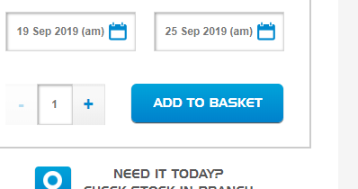

Redirect to /hire/your-basket/precart in CartPageController

1. Before Hitting it using mvc Interceptor **SetHeaderFooterBeforeViewHandler** to set attribute in session

modelAndView.addObject("fromCheckout", true);

1. on redirecting call Post Method preCart() in CartPageController

* CheckBankHolidays
* Checking Stock of Patent Object
* ***service to get real time price for mandatory/optional products via spanner***



* Fetching Tax Values of refrences via db .

refTaxValues = getTaxValues(productModel, form, priceMap);

* Than checking if we have any Mandatory item than increase the count of **precartExtras.**

And Adding it into forms to show on **pre-cart Page**

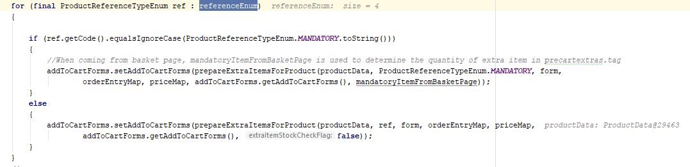

* Fetching **taxValue** for **main Product**.
* If we donot have any product **mandatory and optoional** refrences redirect direct to below url and skip **precart Page**

**"/hire/your-basket/add"**

* ***We are creating a new list to add all non-OPTIONAL and non-MANDATORY extras that are directly passed to the basket page when  
  //precart page is skipped***
* And than ***when kit and option/mandatory products are together added to cart, kit's quantities aren't taken up for contract(can skip this step)***
* Redirect to **precartPage.**

**2) ON** click **PROCEED TO BASKET**

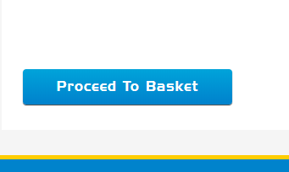

Redirect to **/your-basket/add in addToCartController** and **call addToCart().**

* *Based on the extra items stock level check if not available redirect to* **preCart Page.(check why we r using if all is aleardy false.)**
* Now for Every FormEntry(Product) we are checking
* It contains Promotion or Not.
* Populating **ProductQuantityData** and **OrderEntryData.**
* Adding it to Cart.
* Checking Parent Entry NO is null
* **Yes** than find ***findParentEntryForNextEntry*** *as because parent has no* **ParentEntry.**
* NO populating **ProductData**.
* Checking it has any other product refrences.
* (let check tomorrow by karthik)
* **REDIRECT** to **/hire/your-basket** in CartPageController calling showCart() method
* Adding Some attribute in model.
* Redirecting to **/hire/your-basket/checkout"**
* This step we can Skip as model will destroy in redirection.
* **REDIRECT** to “**/hire/your-basket/checkout"**
* As it is **Secured** so **redirect** to **hire/login/checkout**
* **After** Authentication **redirect** back to “**/hire/your-basket/checkout" in c**artCheck()
* Checking User is Anynomous or B2c.
* Why we are Checking CartFacade.getSessionCart() many times as it is recalculating cartPrice Every time.we can check it through CartData. 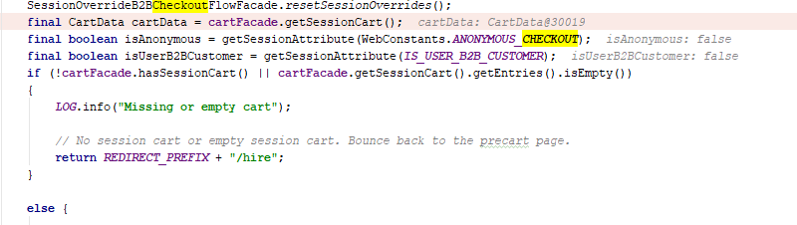

* No session cart or empty session cart. Bounce back to the precart page.
* Otherwise *setting address against the entries Regarding B2b and B2c.*
* Redirect **"/hire/checkout" in Checkout Controller**
* **Check has Entries in Cart**
* **NO REDIRECT to CartPage.**
* **Yes REDIRECT to “/hire/delivery”(Also we can skip this step).**
* Now goto ***firstStep()*** method in ***B2cMultiStepCheckOutController***
* Check ValidCart and **Redirect** to **“hire/delivery/order-review” in**

**orderReviewMethod()** in Same Controller.

* **REALTIMEPRICECHECK on** Entries.
* **STOCKCHECK AND TRANSPORTCHARGESCHECK.**
* cartData = getCheckoutFlowFacade().getCheckoutCart();//use a lot.
* Return **OrderReviewPage.**